Ray Bradbury
Biography

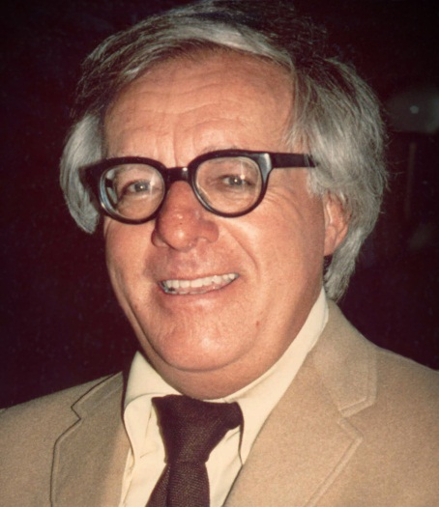

Ray Bradbury was an American science fiction writer whose works were translated in more than 40 languages and sold millions of copies around the world. Although he created a world of new technical and intellectual ideas, he never obtained a driver's license and had never driven a car.
He was born Ray Douglas Bradbury on August 22, 1920, in Waukegan, Illinois. He was the third son in the family. His father was a telephone lineman and technician and his mother, was a Swedish immigrant. In 1934 his family settled in Los Angeles, California. There young Bradbury often roller-skated through Hollywood, trying to spot celebrities. He attended Los Angeles High School, where he was involved in the drama club and planned to become an actor. He graduated from high school in 1938 and had no more formal education. Instead, he learned from reading works of such writers as Leo Tolstoy and Fyodor Dostoevsky, among others.
From 1938-42 Bradbury was selling newspapers on the streets of Los Angeles, spending days in the local library and nights at the typewriter. In 1941 he became a paid writer when the magazine Science Stories published his short story, titled "Pendulum", and he was a full-time writer by the end of 1942. His first book - "Dark Carnival" - was a collection of stories published in 1947. That same year he married Marguerite McClure (1922-2003), whom he met at a book store a year earlier. Maggie, as she was affectionately called, was the only woman Bradbyru ever dated. They had four daughters and, eventually, eight grandchildren.
Ray Bradbury shot to international fame after publication of "The Martian Chronicles" (1950), a collection of short stories partially based on ideas from ancient Greek and Roman mythology. Then he followed the anti-Utopian (against the idea of a perfect world) writers Yevgeni Zamyatin and Aldous Huxley in his best known work, "Farenheit 451" (1953 ). “Farenheit 451” and many of his other novels and stories also have been adapted to films and television, as well as for radio, theatre and comic books. Bradbury had written episodes for Alfred Hitchcock's TV series, as well as for many other TV productions. His total literary output is close to 600 short stories, more than 30 books and numerous poems and plays. He was writing daily.
In 2004 Bradbury received a National Medal of Arts. He was given a star on the Hollywood Walk of Fame, an asteroid has been named in his honor, and the Apollo astronaut named a crater on the moon "Dandelion Crater", after his novel, "Dandelion Wine".
Ray Bradbury died on June 6, 2012, at the age of 91, in Los Angeles, California.

